SWE Vehicle Management System

Team members:

Askaraliyev Nurzhigit - Design of website and application

Chokushev Nursultan - Application Development (main page, sandwich menu)

Durmagambetova Aniyar - Backend for website and application

Issatay Ayan - Application Development (login page)

Jussupov Nizami - Frontend for website

Dinmukhamed Tolegenov - Application Development (debugging)

Web Interface

<https://vms-sigma.vercel.app/auth/login>

Pages:

1. Login Page
2. New Users Registration Page
3. Vehicle Registration Page
4. Task Assignment Page

Driver Application

Pages:

1. Login Page
2. Tasks Page
3. Driver History Page
4. Driver Information Page
5. Main Page with Driver Location

Web

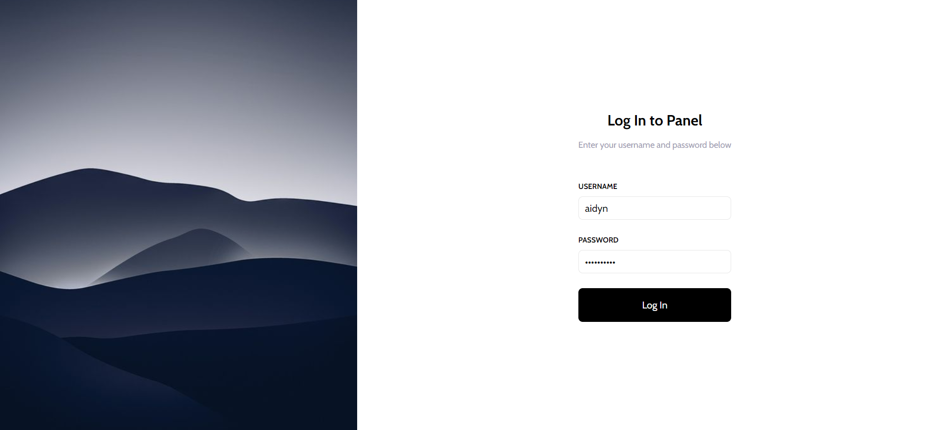

Login page looks like this and allows the administrator to enter the system using his credentials. If successful, he is sent to the main dashboard.

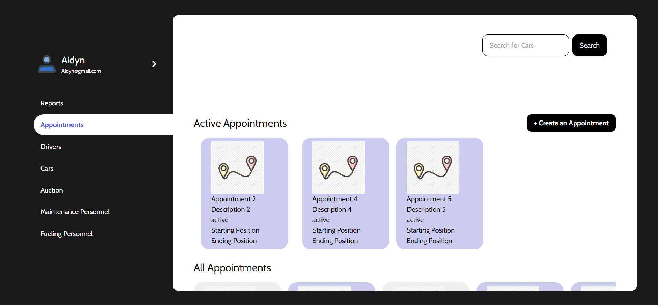

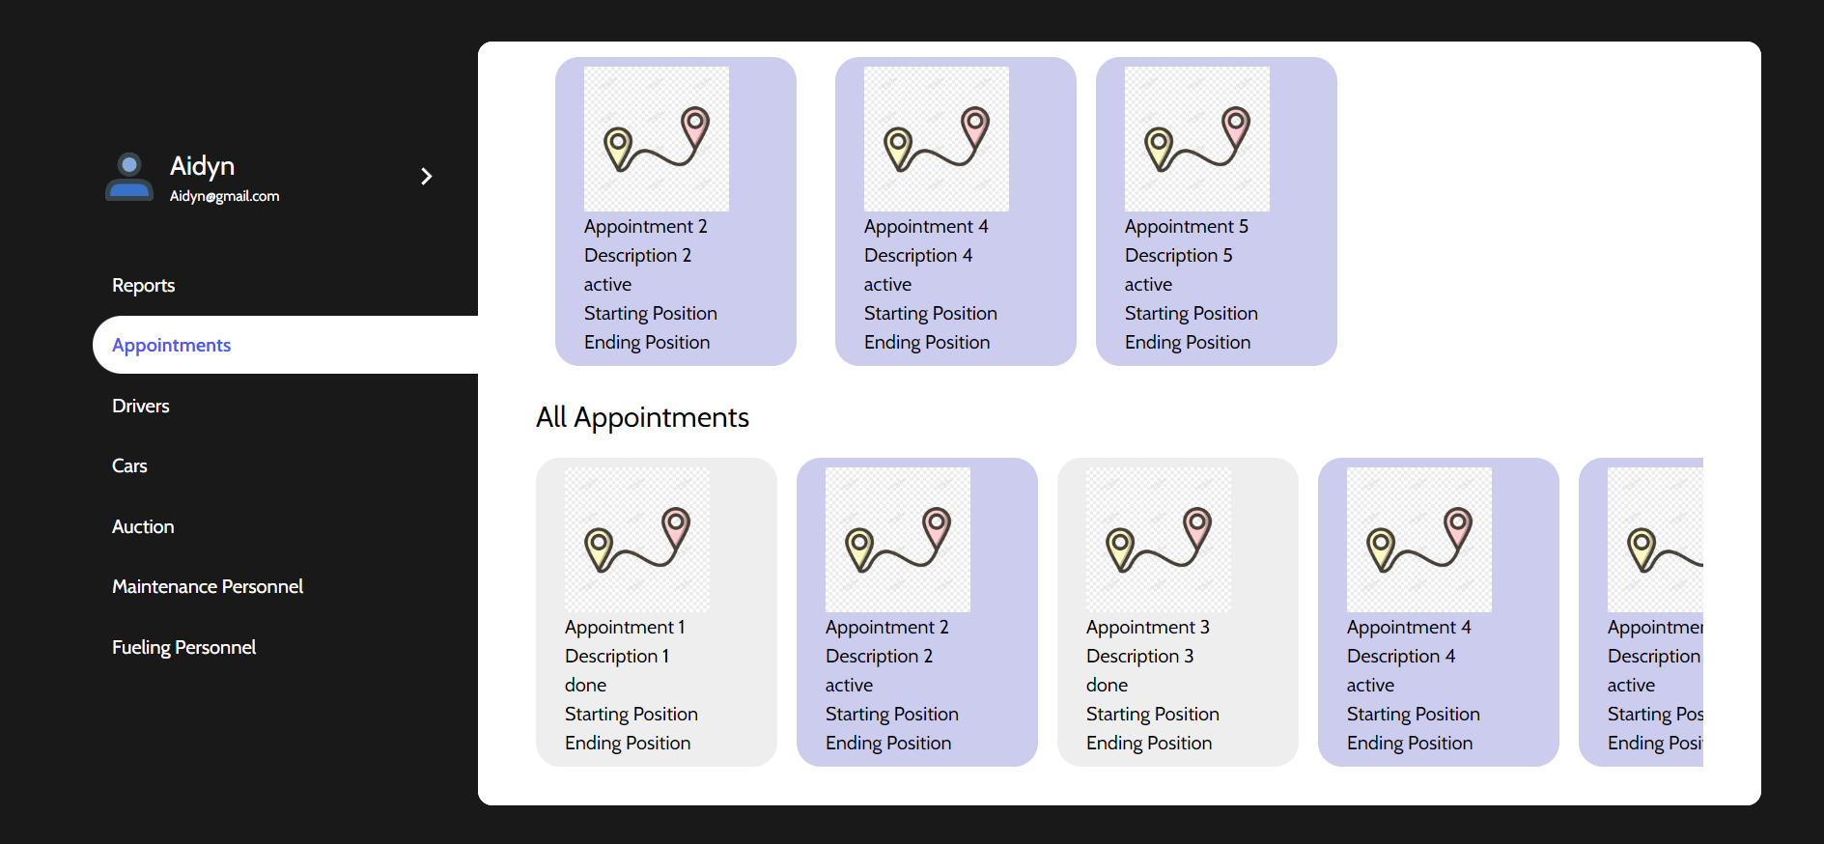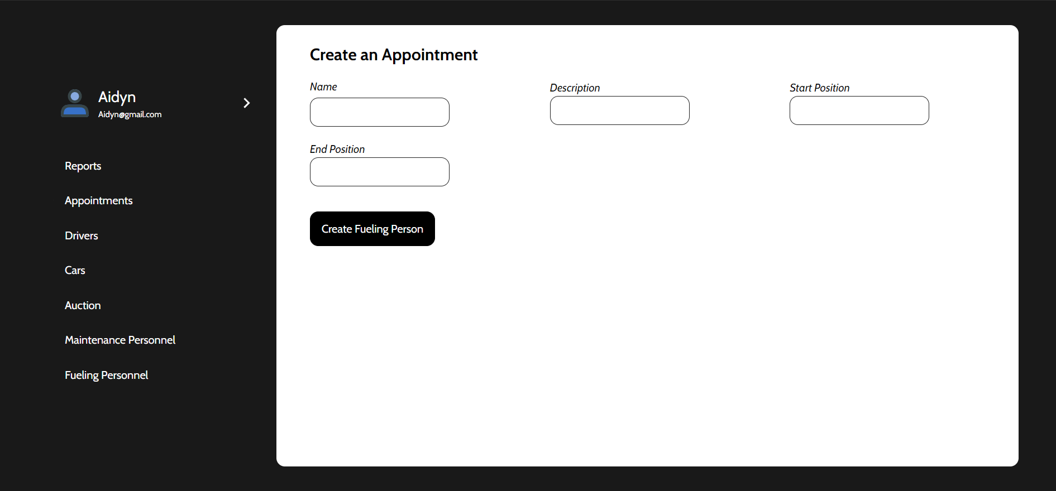

In one of the pages of the admin dashboard he can see all of the active and inactive appointments or tasks that get assigned to each driver individually by the administrator. They provide information on the starting and end destinations. Administrators can add new appointments and save them to the database.

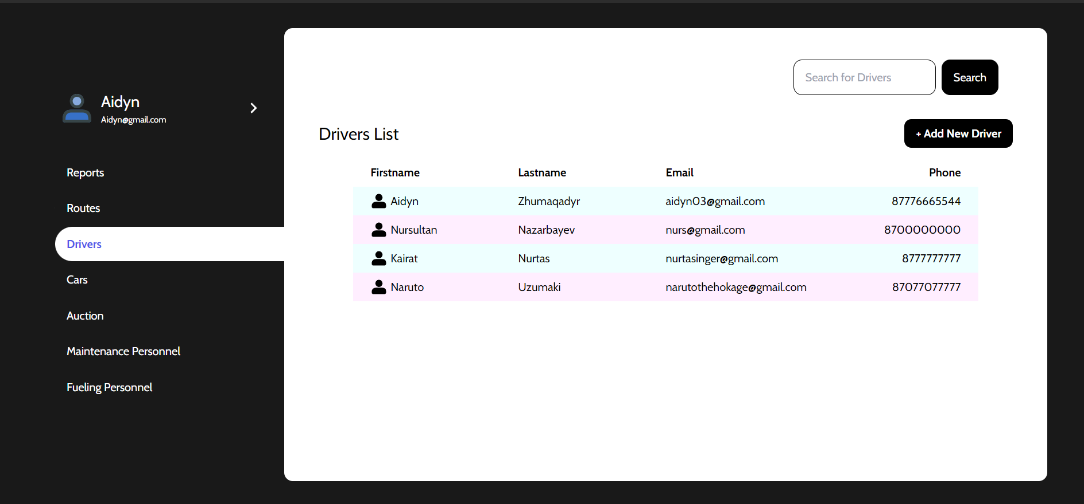

Here is the drivers list that shows all the relevant information about the drivers, whom the administrator can contact either via email or phone. If the drivers list becomes too big in the future, there is a search bar to help administrators find needed drivers faster. Above the table, there is a button, which redirects to the next page.

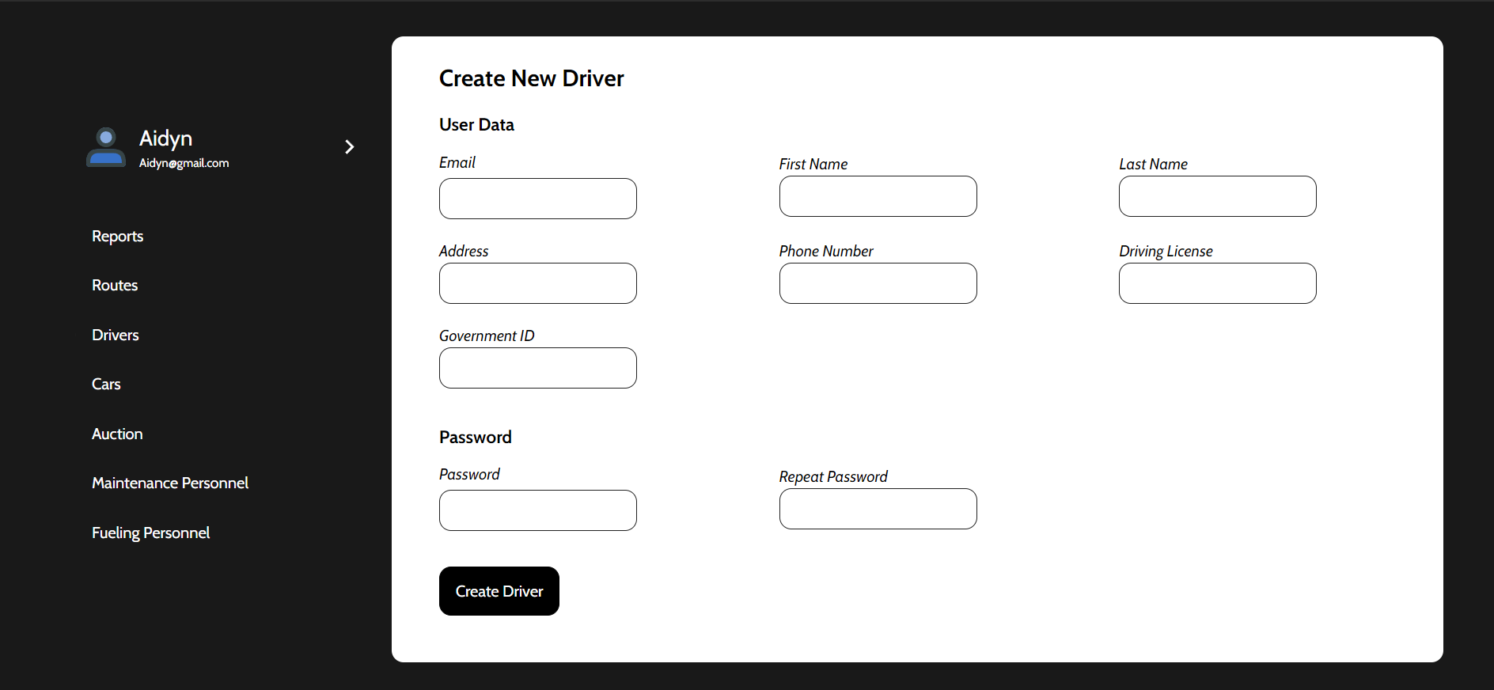

Here the administrator can fill in all information about the new driver and send it to the database. Pretty straightforward new user registration process.

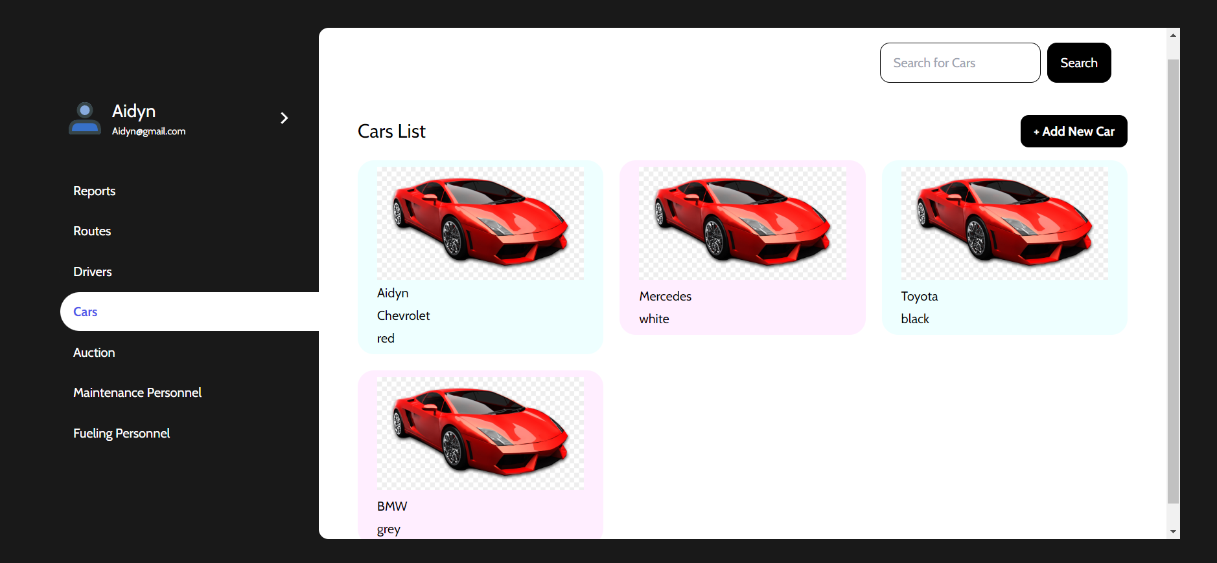

Regarding the cars, we have similar functionality as with the drivers list.

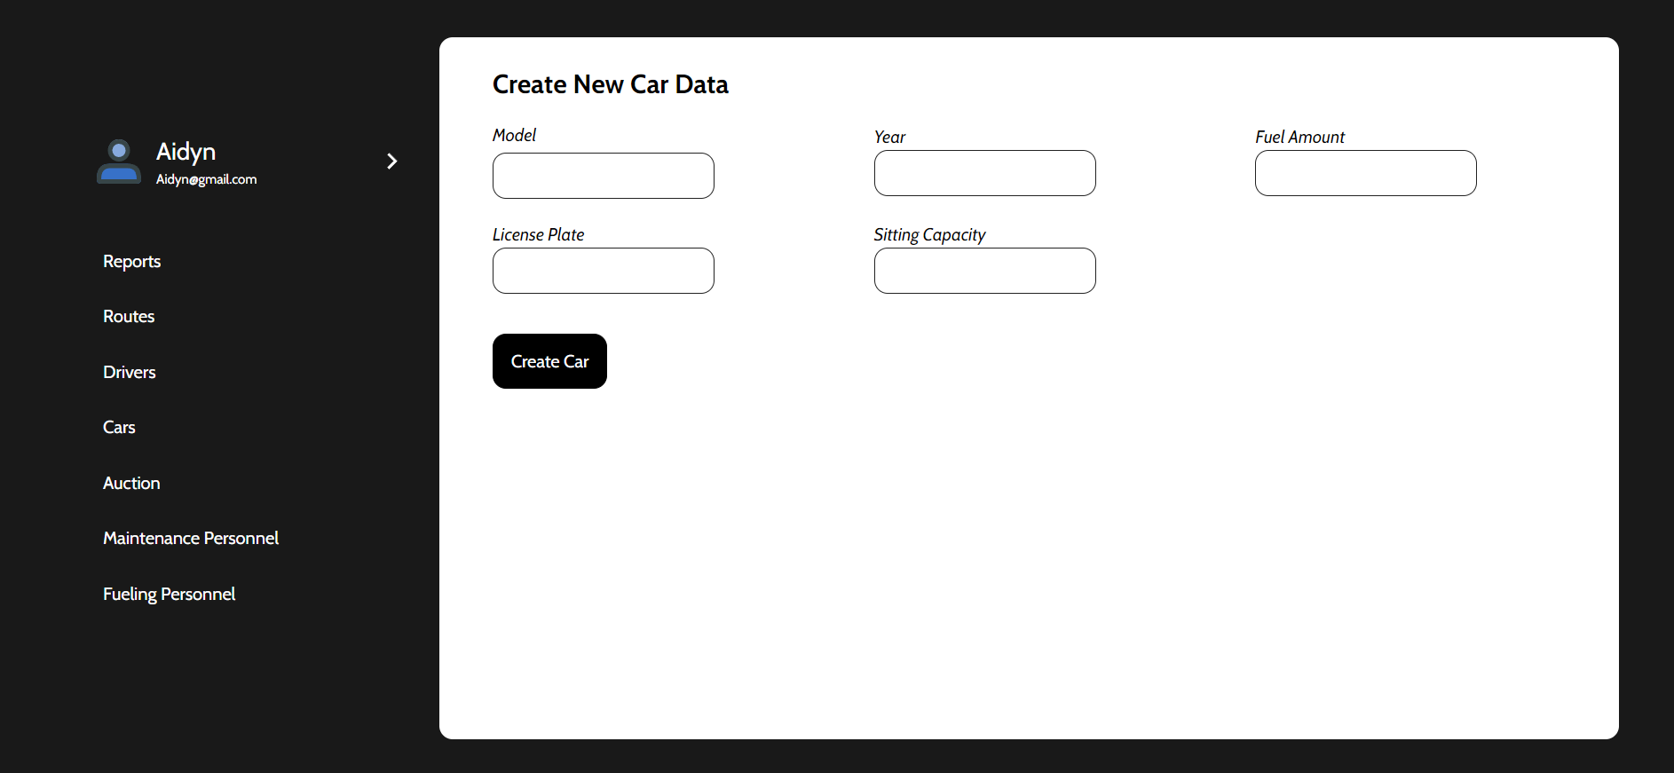

If the new car is added to the system, it is mandatory to fill in the information about the model, year, fuel amount, license plate, and sitting capacity.

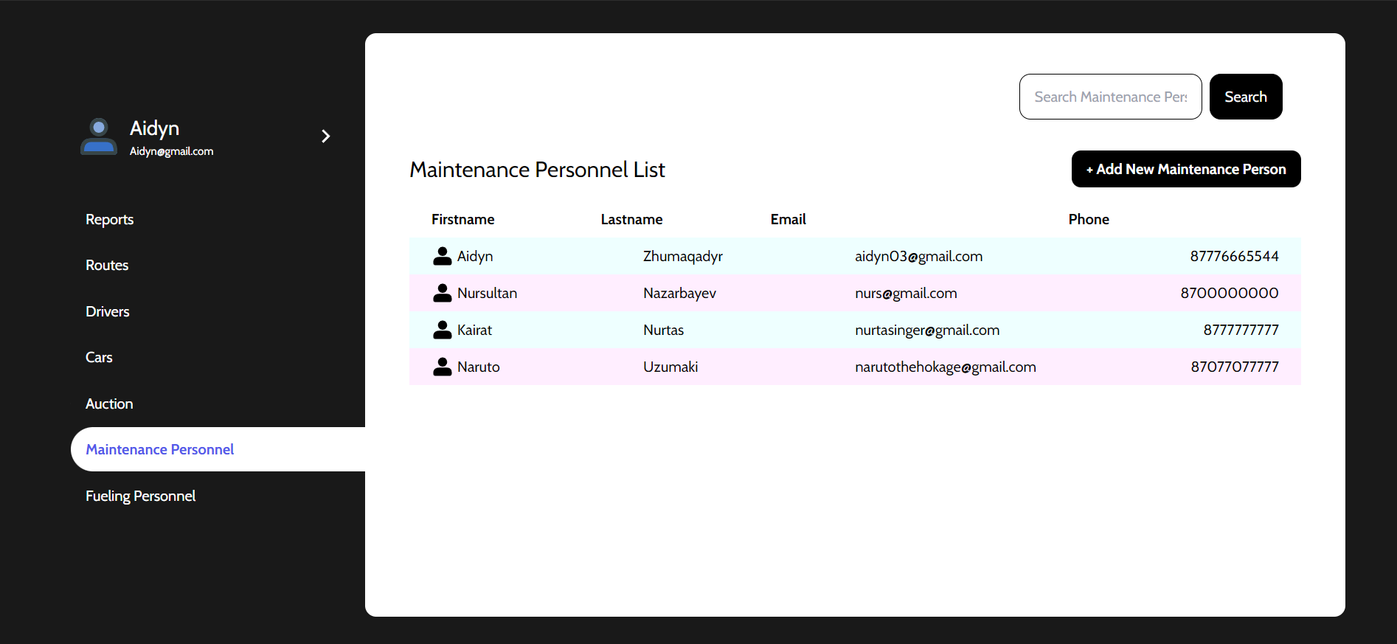

Maintenance people are also a part of the system, so we made their list and registration similar to those of the drivers.

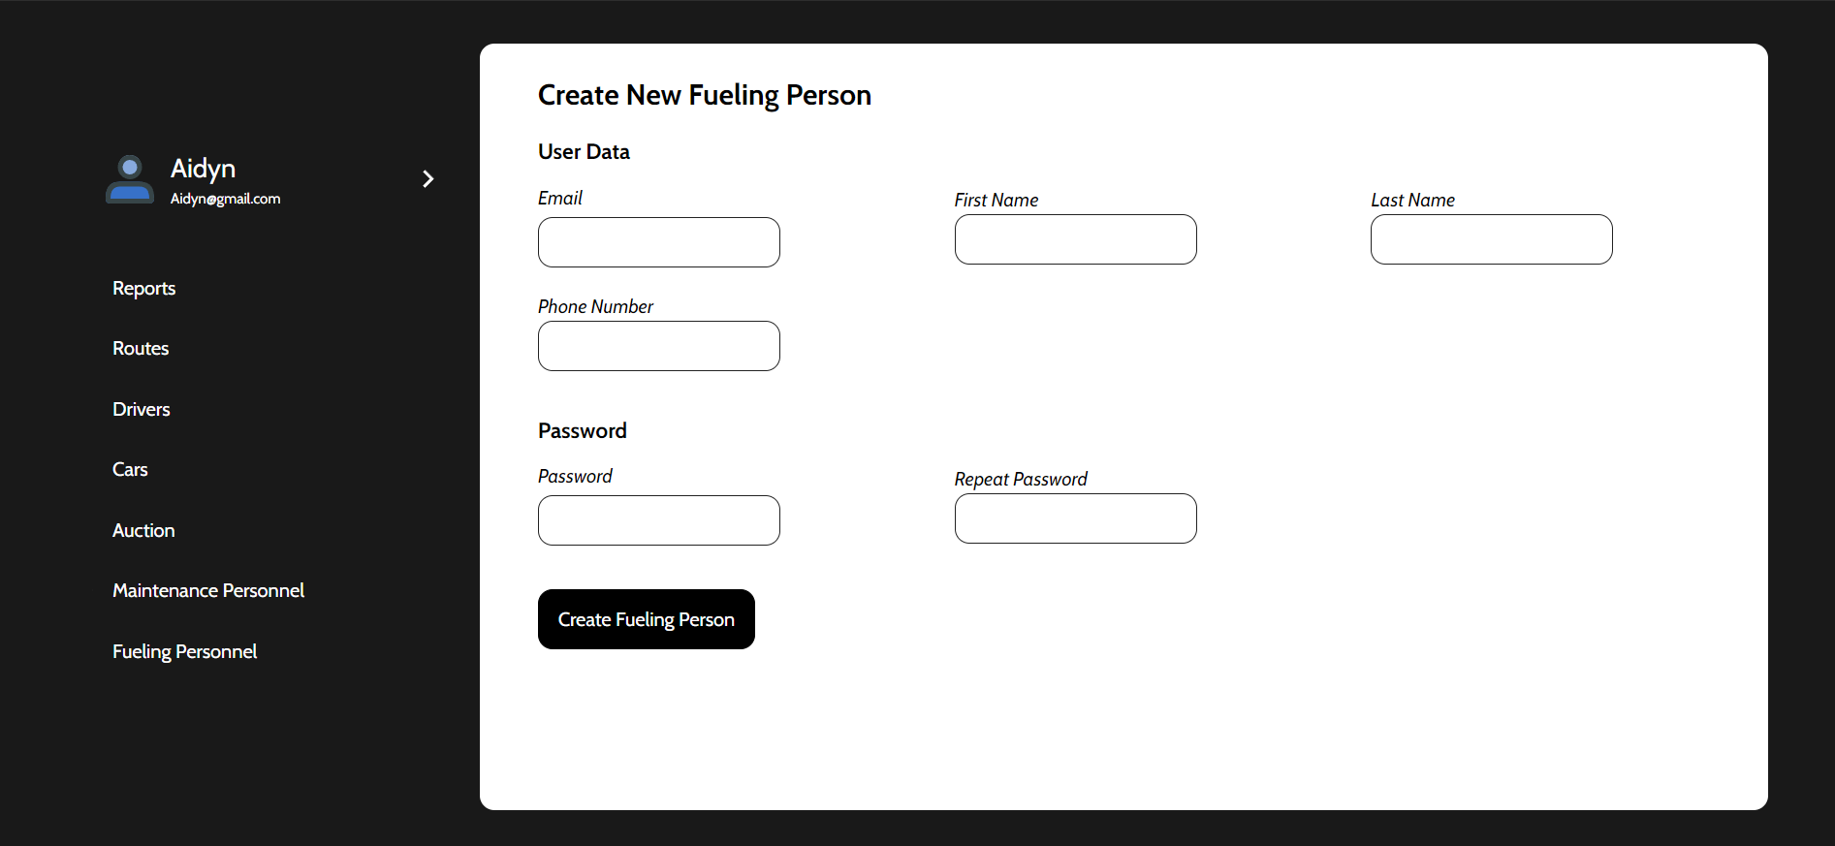

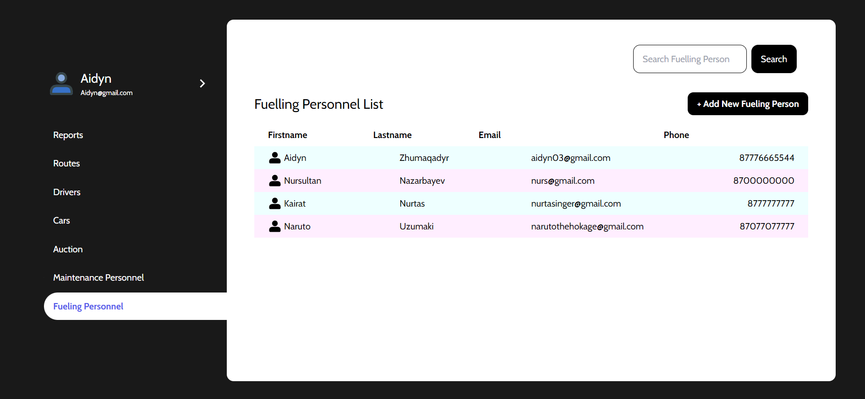

Fueling Personnel list and registration is similar to the Drivers’ and Maintenance’s.

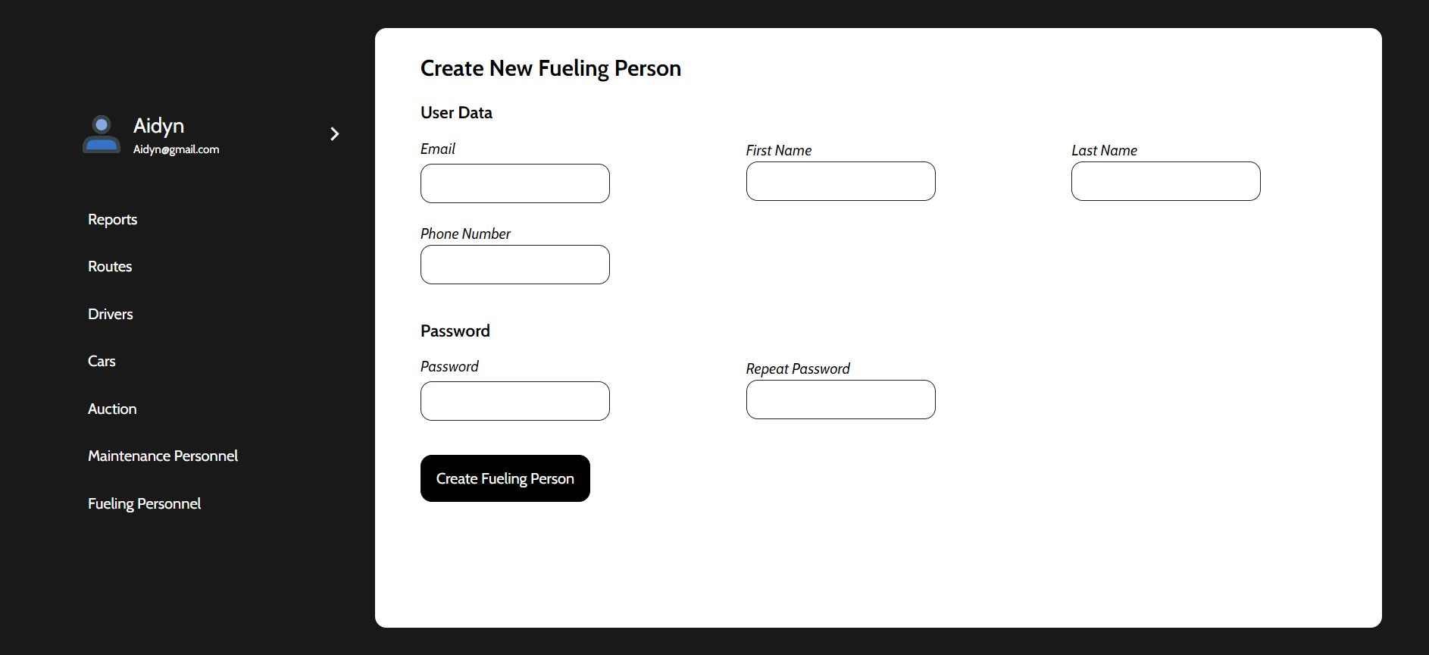

Application

When welcomed in the application, the user is shown a login page, where he or she needs to enter correct username and password, or if not registered in the system, contact the administrator and provide details further explained by the administrator.

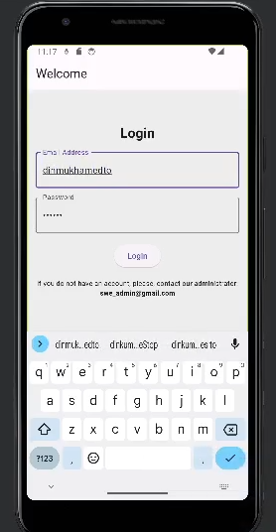

After successful login, the user is redirected to the Main Page with the map that shows the user's current location on the map. It also shows the destination and the path to it, making it easier for drivers to navigate.

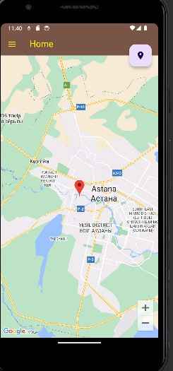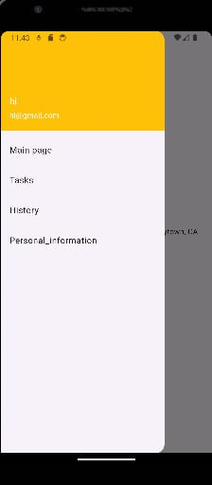

Here, there is a sandwich menu for the smooth navigation of the user between tabs. There is a map with the user's location and if he is assigned any tasks, then he gets them shown on the map as well.

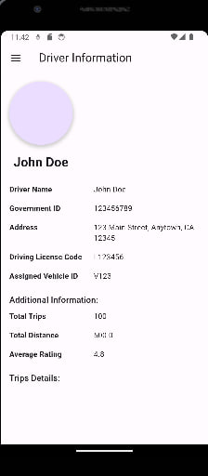

Users can see information about himself and overall statistics. If the provided information is incorrect he can contact the administrator to correct it.

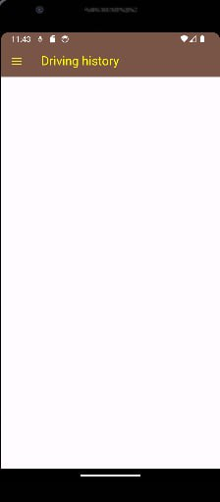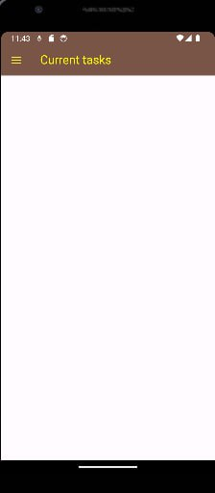

For this user, currently there are no tasks or driving history; however, we will correct it in the future versions of this application.